Automated LinkedIn Job Scraper & Outreach System

Welcome to the Automated LinkedIn Job Scraper & Outreach System! This innovative n8n template is meticulously crafted to replace traditional, time-consuming lead generation methods by zeroing in on companies that already signal a genuine need (e.g., hiring SDRs). By merging specialized scrapers like Apify and AnyMailFinder with AI-driven personalization, you can drastically improve your outreach efficiency and conversion rates. In essence, this workflow flips the script on standard cold emailing: instead of blasting generic messages to broad lists, you’ll focus on real-time market signals—ensuring that each lead is both relevant and likely to convert.

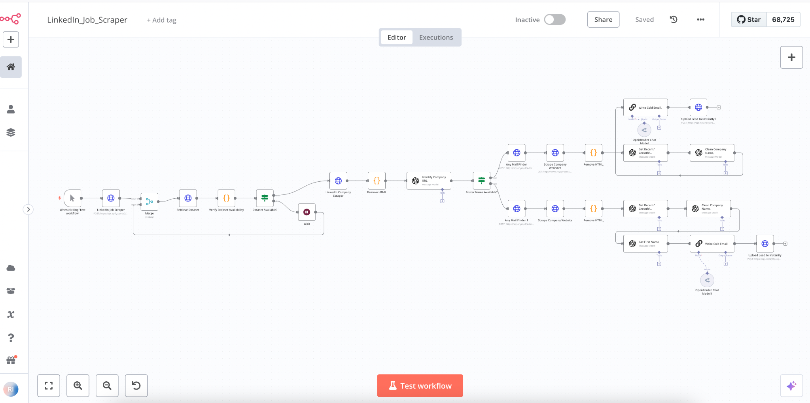

🚀 Features Overview
The system is organized into five segments:
- Scrape Companies Hiring for SDRs
  - Use LinkedIn and similar job boards to locate job postings for SDRs.
  - n8n triggers Apify’s LinkedIn Job Scraper via HTTP, then waits until fresh data is available.
- Retrieve Company Emails
  - Scrape the company’s LinkedIn profile for a domain.
  - Feed the domain into AnyMailFinder to collect valid email addresses.
- Enrich Leads & Personalize
  - Fetch and clean the company’s homepage HTML.
  - Use AI prompts to identify testimonials, recent growth, and success stories for personalization.
  - Clean up “Inc.,” “LLC,” and similar suffixes from the company name.
- Extract First Name
  - An LLM isolates and capitalizes the first name from the email address.
  - Ensures a human touch in your greeting.
- Send Automated Outreach Email
  - A pre-tested cold email template inserts placeholders (first name, relevant pain points).
  - Emphasizes proven benefits (e.g., higher volume, better engagement).
  - Automatically sends the email and can schedule follow-ups.

🎥 Workflow Demonstration
Explore the workflow in action and understand its functionality with this detailed video guide:

https://youtu.be/Zc1rxQJGgKo

📋 Step-by-Step Guide
A. Scraping LinkedIn Job Listings
- Tool: Apify’s LinkedIn Job Scraper.
- Trigger & Wait: n8n HTTP POST node supplies parameters (role, location), triggers the scraper, and waits for the dataset to be ready.
B. Finding the Domain & Emails
- LinkedIn Profile HTML: Retrieve profile data, strip out code, and prompt an AI to detect the company domain.
- AnyMailFinder: Input the domain to get all associated email addresses.
C. Enriching Lead Data
- Website Scrape: Similar method fetches homepage content in plain text.
- AI Analysis: Summarizes any testimonials and growth stories for personal touches.
- Company Name Cleanup: Removes corporate suffixes for a more natural mention in outreach.
D. Personalizing the Greeting
- First Name Extraction: AI picks out the user’s first name from the email.
E. Writing & Sending Emails
- Template Merging: Inserts name and personalization snippet into the cold email.
- Efficiency Pitch: Shows how the system delivers results better than typical SDR outreach.
- Automation & Follow-Up: n8n handles the delivery, optionally scheduling subsequent emails if no reply is detected.

Results & Impact
- The automated system reduces day-to-day work to only 3–4 hours by offloading tasks to AI.
- Highly targeted leads—companies explicitly hiring for roles you can fulfill—yield better responses and conversions.

